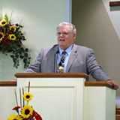

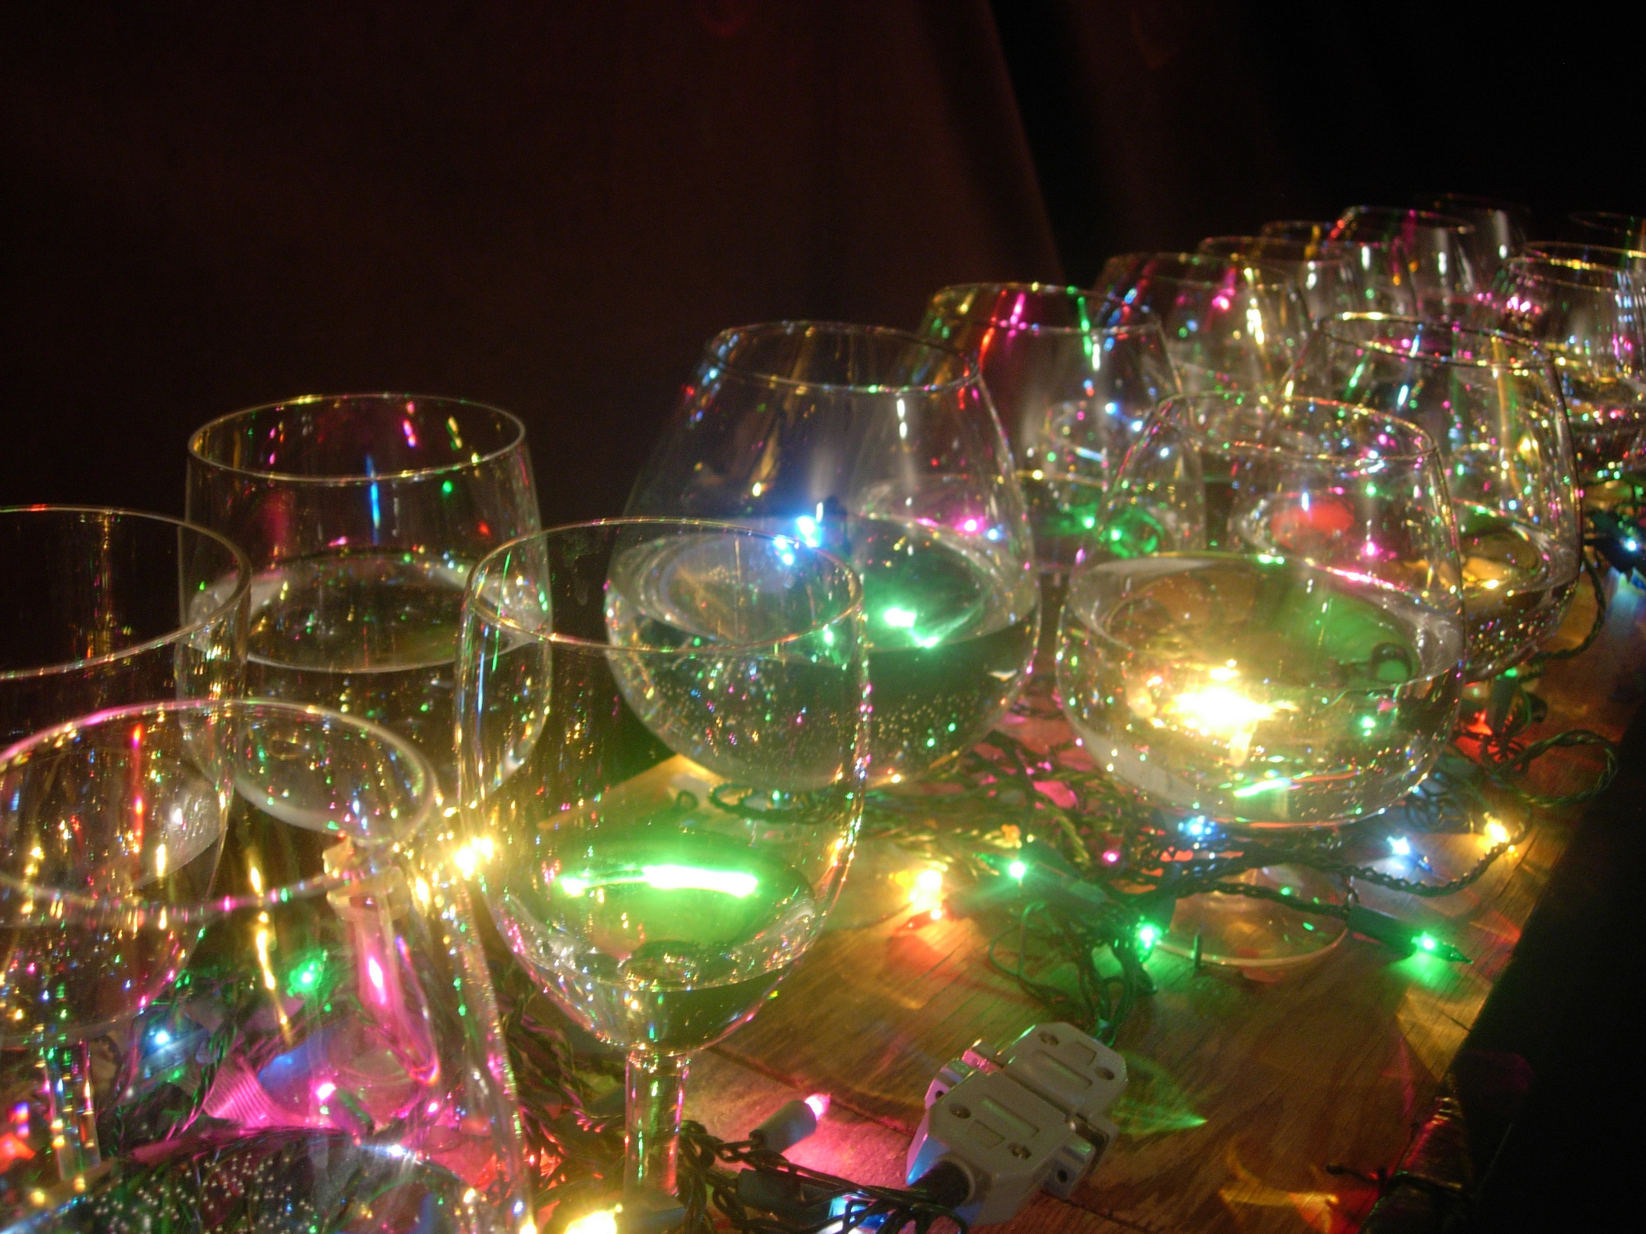



***YOU ARE INVITED***

***to hear***

***Evangelist Ken Lynch***





***YOU ARE INVITED***

***to hear***

***Evangelist Ken Lynch***

***YOU ARE INVITED***

***to hear***

***Evangelist Ken Lynch***









**Sound Bible Preaching**

**Violin**

**Musical Glasses**

**Vibraharp**

**Clavinova**

**Filipino Bandura**

**Sound Bible Preaching**

**Violin**

**Musical Glasses**

**Vibraharp**

**Clavinova**

**Filipino Bandura**

**Sound Bible Preaching**

**Violin**

**Musical Glasses**

**Vibraharp**

**Clavinova**

**Filipino Bandura**

**Sound Bible Preaching**

**Violin**

**Musical Glasses**

**Vibraharp**

**Clavinova**

**Filipino Bandura**

* **Sound Bible prea**
* **Musical Glasses**
* **Vibraharp**
* **Clavinova**
* **Bandura**

***YOU ARE INVITED***

***to hear***

***Evangelist Ken Lynch***